To whom it may concern

DELEMONT, 19th of October 2023

Import restrictions products originating from Russia
Dear Valued Customer,

We confirm that we are compliant with the Council Regulation (EU) No 833/2014 and its subsequent (i.e.: Council Regulation (EU) 2023/1214) and that we do not import/purchase any products such Annex XVII from Russia or exported from Russia.

Best Regards,

PRECI-DIP SA PRECI-DIP SA
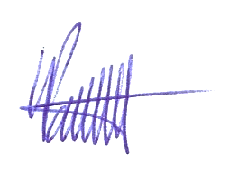
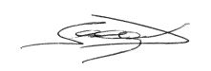

Seeger Jordan Pantet Laurent
Supply Chain Management Quality Management

